MASCHERPA Audric ROB 3 2022 / 2023

**POLY-SNAKE**

**Weekly report n°13 from 14/02/23 :**

first of all, the wheels previously ordered coming from the USA, new wheels of French origin were favored in order to reduce the transport time and to have them as quickly as possible. Here are the wheels chosen in figure 13.1 very similar to the one chosen the last session.

Figure 13.1

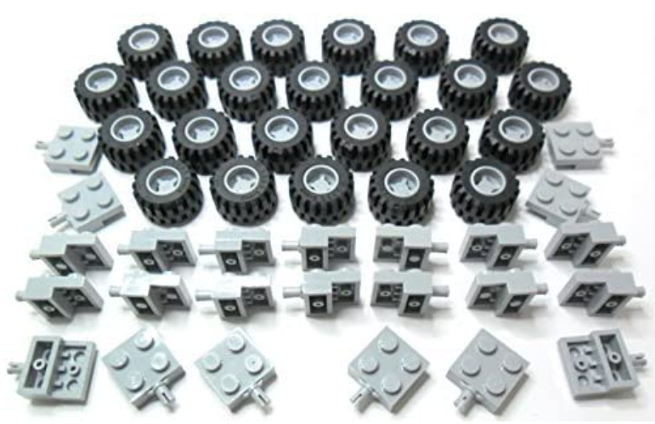

Then, while waiting for the material to arrive, the 3D modeling of the body of the snake has been completed. The latter is inspired by all the models previously made in order to have the most optimal 3D pieces in terms of resistance, design, size, and utility.

Thus, in Figure 13.2 is a 3D model of the snake's head containing the rasebery nano card as well as the camera and space to add other items. Also in Figure 13.3 is a model of the snake's tail containing the battery (in orange) and the Arduino board (in dark blue).

Figure 13.3

Figure 13.2

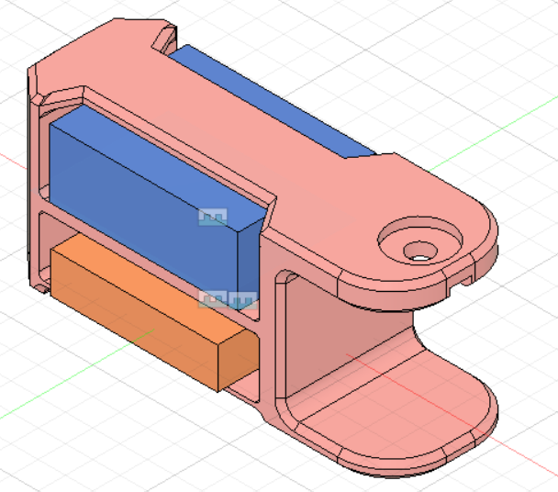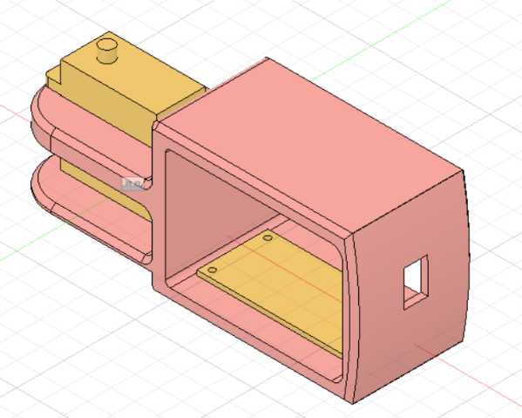

It is important to emphasize that this 3D modeling aims to carry out the first tests of the advancement of the snake once the wheels have been delivered. This is why the aesthetic aspect has not yet been added.

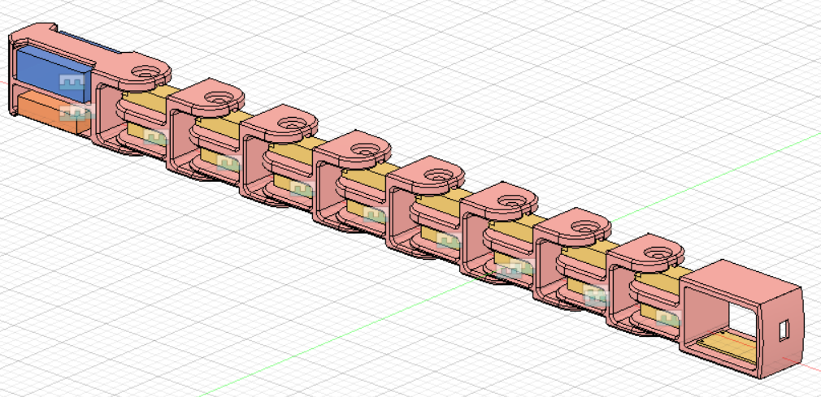finally, we can see in figure 13.4 the 3D modeling of the entire body of the snake.

Figure 13.4